**EE345L – Lab 3: Alarm Clock**

Ty Winkler and Jeremiah Bartlett

02/12/16

1. **OBJECTIVE**

In this lab we designed and tested an Alarm Clock. This lab was designed to teach us how to build and test modules that can be brought together to create one system. Using the TM4C123, buttons, and a speaker individual modules will be created and tested, such as, an input module, a time management module, a LCD module, and a sound module. After each module is built and tested a final system will be built and tested as well.

1. **ANALYSIS AND DISCUSSION**
   1. **Critical Sections**

Critical Sections can be prevented by stopping interrupts before reading or writing to a global variable. Critical Sections can also be avoided by locking the read or write to make sure that it is finished before continuing with interrupts.

* 1. **LCD Update**

The LCD has a refresh rate of about 150ms, which is to say the screen can update with new pixel information once every 150ms. This however can change based on the software rate at which data is sent to the LCD.

* 1. **LCD Update during ISR**

Updating the LCD during the ISR would cause the LCD to get display information once every time the ISR is triggered. This can cause issues if the ISR is set to a slower rate than when the LCD is needed to be updated.

* 1. **LCD Redraw**

The LCD redraw module was designed to redraw the LCD once every loop even if a time update had not occurred. This means variables that contributed to the drawing of the LCD could be updated independently of the LCD redraw and at a much more consistent rate causing less flicker.

* 1. **Saving Power**

If the system was battery powered power can be saved by designing the system around positive logic, by using a lower volume with the speaker, and by triggering time interrupts and screen updates less often.

1. **Software & Hardware Design Solutions**
   1. **Hardware Design**

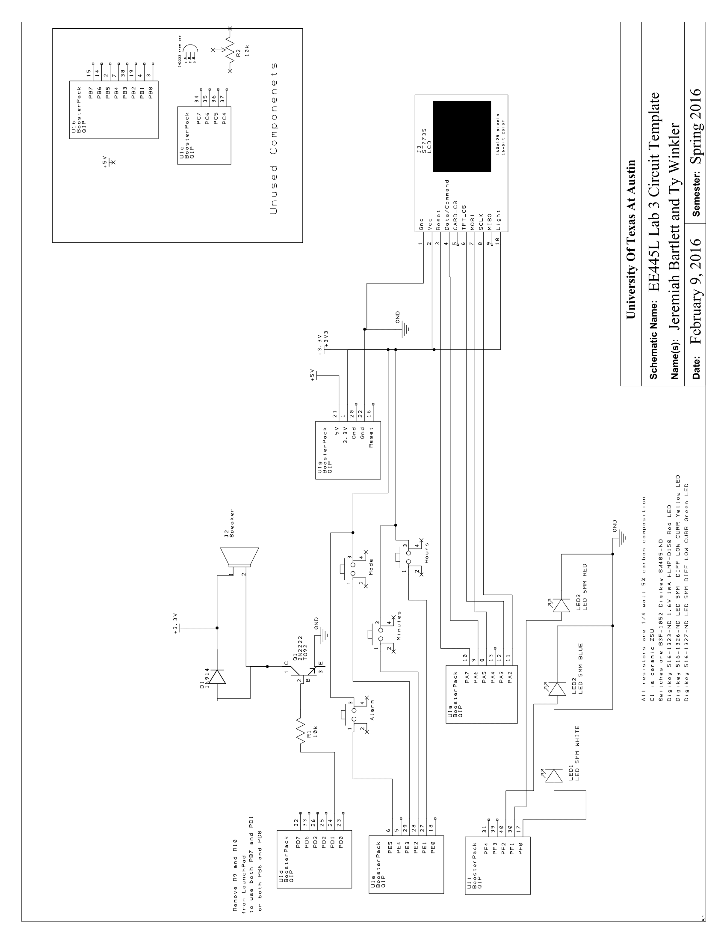

* 1. **Measurement Data**

5V supply voltage vs Time

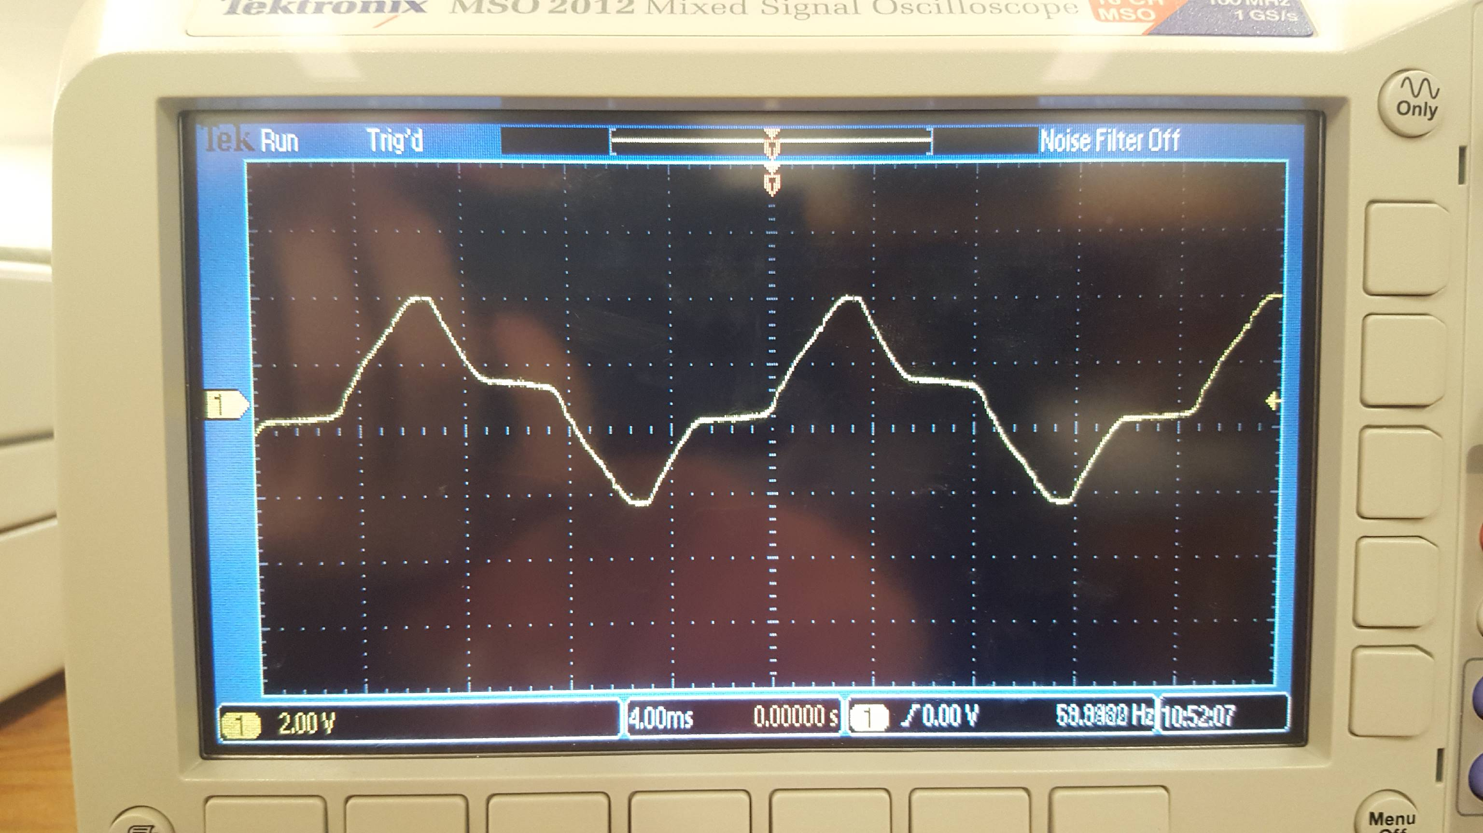

3V supply voltage vs Time

